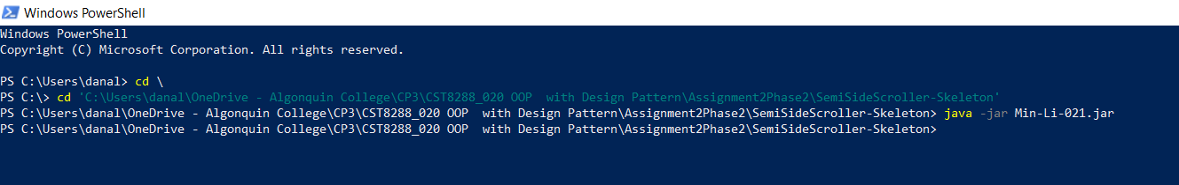

Hi Professor Shawn,

This is Min.

Just want to let you know that I can run my jar file in Windows PowerShell.

Thanks!